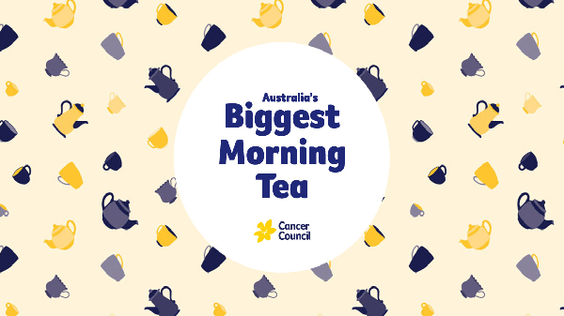

**We would like to invite you to participate in Australia’s Biggest Morning Tea hosted by the Year 8 Food classes at NSHS**

**To: ______________________________**

**Where: _____________________________**

**Date: ______________________________**

**Time: _______________________________**

**From: _______________________________**

**A donation to the Cancer Council would be appreciated**